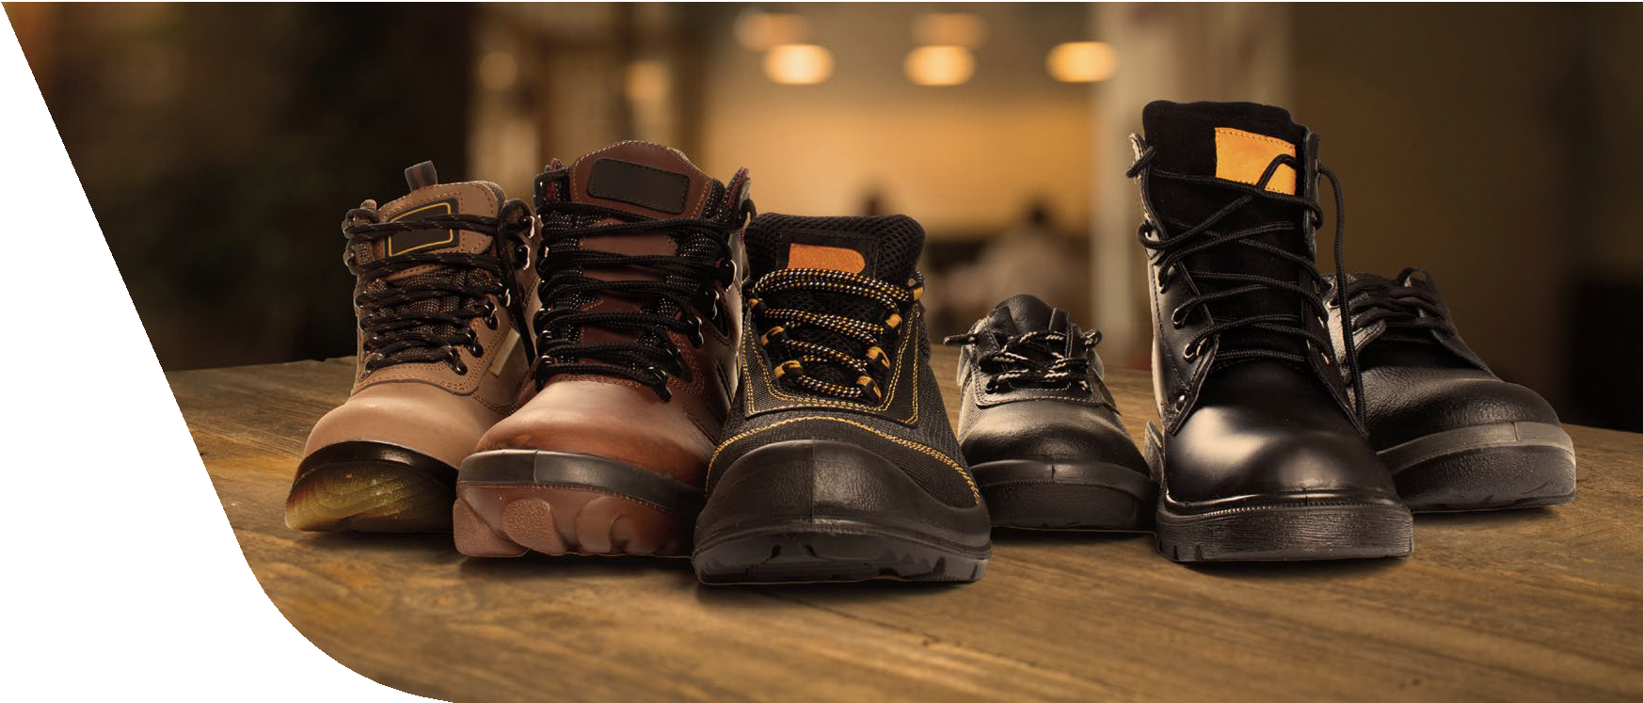
Slip Resistant Footwear Policy
- Stepstools and Ladders
- Tripping Hazards: Clutter, Loose Cords, Hoses, Wires
- Improper Use of Floor Mats and Runners
- Contaminants on the Floor
- Poor Drainage: Pipes and Drains
- Indoor Walking Surface Irregularities
- Outdoor Walking Surface Irregularities
- Weather Conditions: Ice and Snow
- Inadequate Lighting
- Stairs and Handrails

What Causes Slips and Trips?
Both slips and trips result from an unintended or unexpected change in contact between the feet and the ground or walking surface. NIOSH lists these top 10 workplace slip hazards:

Why is a Policy Necessary?

OSHA Compliance
The Occupational Safety and Health Administration (OSHA) requires employers to assess workplace hazards and provide appropriate Personal Protective Equipment (PPE), which can include slip-resistant footwear in environments with wet or oily surfaces.

Preventing Injuries
Slip-resistant footwear is crucial in preventing slip, trip, and fall accidents, a leading cause of workplace injuries.

Reducing Liability
By proactively addressing slip hazards, employers can lower the risk of serious injury-related costs and potential liability.
A slip-resistant footwear policy mandates employees to wear specialized, high-traction shoes to prevent injuries from slippery workplace conditions, often required by employers to ensure compliance with OSHA regulations and protect employees. Such a policy specifies the type of approved footwear with features like non-skid soles and grooved treads to channel liquids, outlines employee responsibilities, and details the employer’s role in providing guidance or reimbursement.

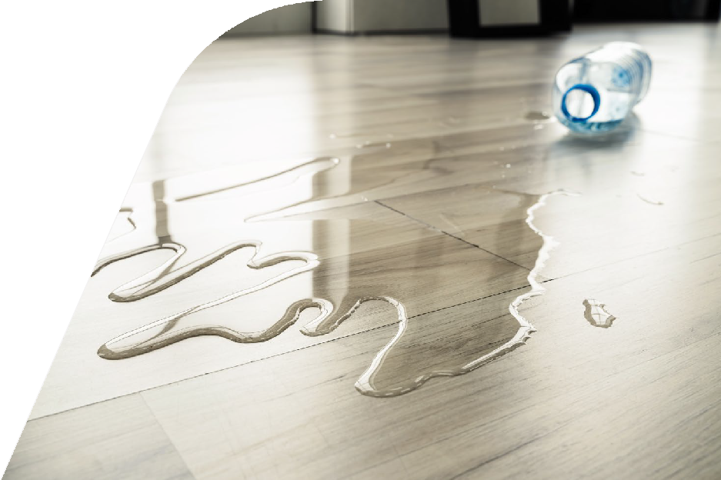
Slip and fall hazards can occur in almost any workplace. Use this information to help reduce hazards and train workers to avoid slips and falls.

When Using Floor Mats
- Do mats have abrupt squared-off edges, lacking a bevel?
- Are mat edges curled up or flipped over? Do mats slide around on the floor?
- Are floor mats worn or damaged increasing potential of trips?

How to Prevent Slips and Trips
- Clean up spilled liquids promptly
- Provide non-slip surfaces on floors that will be wet
- Use slip-resistant footwear
- Keep hallways, stairs and walkways clear of clutter
- Ensure aisles are wide enough for the intended use
- Make sure stairs have proper handrails, that treads and risers are maintained, and that treads have a slip-resistant surface
- Include guardrails, toe boards and permanent means of access for elevated storage and work surfaces
- Cover floor drains with grates Bundle cords using a cord organizer
- Cover cords on the floor with a beveled protective cover or tape

How to Identify Slip & Trip Hazards

On Indoor Walking and Working Surfaces
- Do tiles, linoleum, or other flooring have holes, cracks, or bumps?
- Is carpeting buckled, loose, or frayed? Are carpet edges curled up?
- Does floor feel greasy or slippery?
- Are liquid contaminants present (water, grease, oil, cleaning solutions, coffee)?
- Are dry contaminants present (powder, peanut shells, dirt, flour, food)?
- Are there sudden changes in indoor floor elevation (more than 1/4 inch?
- Are there metal grates or mesh flooring in the walkway?
- Are water absorbent walk-off mats used in entrances?
- Are slip-resistant mats used in wet areas?

On Outdoor Walking and Working Surfaces
- Are there gaps, cracks, or holes in the outdoor walkway of more than 1/2 inch?
- Are there metal grates or mesh flooring in the walkway?
- Is the walkway uneven, with abrupt changes in level?
- Is there debris (pebbles, rocks, leaves, grass clippings) on the walkway?
- Are there any slippery conditions present (water, grease, ice, snow)?
- Are concrete wheel stops in the parking areas highlighted with paint?
- Are changes in elevation in parking areas highlighted with paint?

Risk Specific Footwear
Employees working in or around operations resulting in wet or slippery floors are required to wear slip resistant soled shoes. Employees will be responsible for inspecting their footwear regularly to ensure they are in good condition and still provide adequate slip resistance.
Employees will wear footwear appropriate for their assigned work activities and site conditions.
Examples of appropriate footwear include shoes with:
- Closed toes and defined heels
- Low heels that provide good ankle support and stability (heels 1” or less in height and heel base width 1” minimum)
- Non-slip soles
Note: Winter footwear should be considered during winter weather conditions.
Examples of inappropriate footwear include:
- Flip flops or beach shoes
- Open-toed or open-backed shoes Slides or mules (backless shoes) Sandals
- Footwear with heels greater than 1” Shoes with spiked heels
- Platform shoes (soles greater than 1”)
- Molded or plastic “gummy” shoes or “Crocs”

Slip Resistant Footwear Program

Purpose
[INSERT COMPANY NAME] recognizes that slips and falls in the workplace are a leading cause of serious injuries. This program has been established to provide information and practices to minimize risks while working in the hospitality industry.

Responsibilities
Management and supervisors will be responsible for assuring that they and all employees understand the need for proper footwear and for enforcing appropriate disciplinary action procedures where footwear is not worn properly. Employees are responsible for wearing proper footwear anytime in the restaurant.
[INSERT GENERAL MANAGER] will be responsible for the implementation, evaluation and effectiveness of the Footwear Program within their facility. The [INSERT AREA SUPERVISOR AND SAFETY DESIGNEE] will be responsible for evaluating the planned work, both current and new, to reduce or eliminate hazards that would otherwise require the use of protective footwear. Where these hazards cannot be effectively eliminated, protective footwear appropriate to these exposures will be determined and required.
Failure to wear safety footwear as required by this policy will be treated in accordance with [INSERT COMPANY NAME] disciplinary action procedures which include possible termination of employment.
Content provided by ComplianceSigns.com
This material is for general information only and should not be considered as a substitute for legal, medical, tax and/or actuarial advice. Contact the appropriate professional counsel for such matters. These materials are not exhaustive and are subject to possible changes in applicable laws, rules, and regulations and their interpretations.
NPN 1316541 | IMA, Inc dba IMA Insurance Services | California Lic #0H64724
IMACORP.COM
©IMA Financial Group, Inc. 2025
CT-MP-IMA-H-RC-101325

